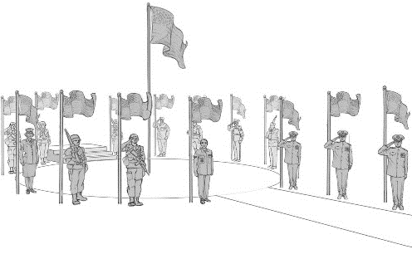
Colerain Veterans Memorial Sponsor Sheet

  - If you would like to sponsor, please fill out the following document and email to colerainveteransmemorial@gmail.com or mail to Colerain Veterans Memorial P.O. Box 532196 Cincinnati, Ohio 45252
  - Colerain Veterans Memorial is a non-profit group with a Federal EIN number:
  - EIN 82-3497343

Company or Name: _____________________________________________________________________
Contact Name: ________________________________________________________________________
Address: _____________________________________________________________________________
City: ____________________________ State: _________________ Zip Code: ______________________
Phone: ________________________ Fax: ____________________ Email: _________________________

I would like to sponsor (Please Circle): Flag Pole -> $2,000.00
Engraved Granite Bench -> $6,000
Bronze Statue -> $30,000
Bell Tower-> Prices Vary
  - Bell Tower Sponsor ONLY
I would like the name on (Please Circle): Outside Legs of Tower-> $1,000.00
Inside Legs of Tower -> $500.00
  - Further Detail of Sponsored Items:
Company Name or Personal Name will be displayed on bronze plate for the Flag Pole
Company Name or Personal Name will be displayed on the face of the bench seat for Granite Bench.
Company Name or Personal Name will be displayed on base of the statue for the Bronze Statue.

